**Smart Home Automation System**

Project Proposal-1

**Tentative Outline:**

|  |  |
| --- | --- |
| 1. | Objective |
| 2. | Equipment   * Requirement Table * Arduino UNO Pin Diagram * HC-05 Bluetooth Module Pin Diagram |
| 3. | Block Diagram of Smart Home Automation System |
| 4. | Circuit Diagram of Smart Home Automation System |
| 5. | Working Principle   * Load Values of the App Buttons * A Brief Explanation on how the System works |

**Project Objective:**

The objective of this project is to implement a cost-effective, reliable, and scalable **Home Automation System** that can be used to remotely switch on or off any household appliances. This project helps the user to control all the electronic devices using his/her smartphone via Bluetooth. Users can turn on/off their home appliances in the range of Bluetooth.

**Project Equipment:**

|  |  |
| --- | --- |
| **Products** | **Quantity** |
| Arduino UNO | 1 |
| PCP Prototyping Board | 1 |
| 4 Channel Relay Module | 1 |
| HC-05 Bluetooth Module | 1 |
| AC Bulb with Holder and Wire | 4 |
| Smart Phone | 1 |
| Bluetooth Controller App | 1 |
| 220V AC Power Supply |  |
| Connecting Wires |  |
| 9V 1amp Adapter | Required |
| External DC Power Supply for Operating Arduino |  |

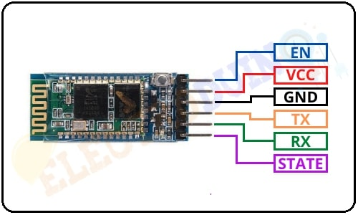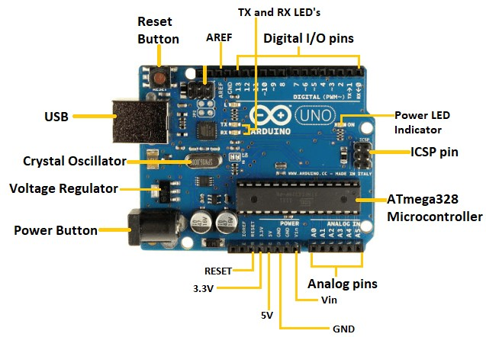

Arduino UNO

HC-05 Bluetooth Module

**Block Diagram:**

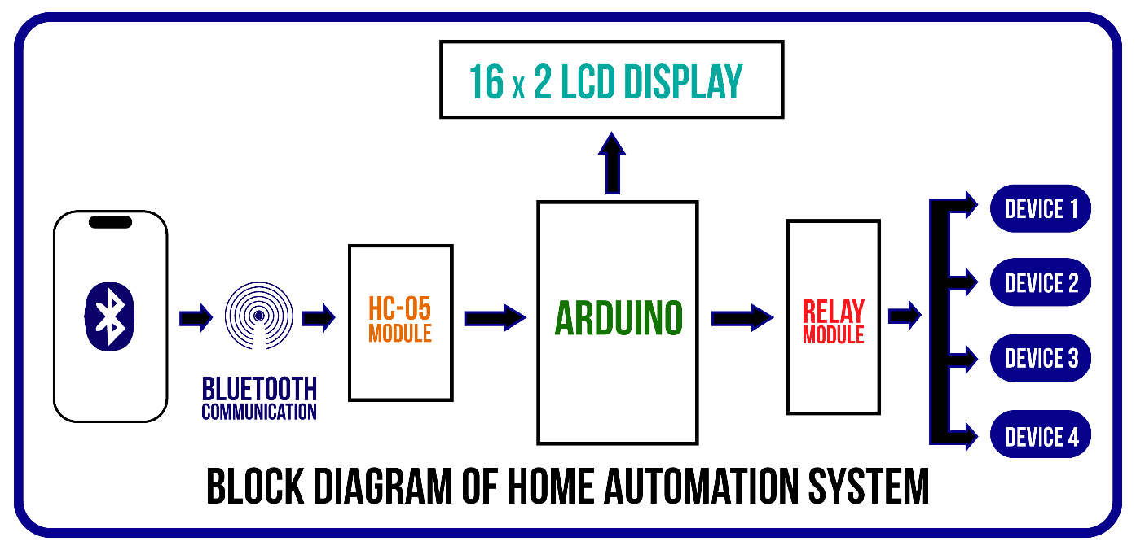

**Circuit Diagram:**

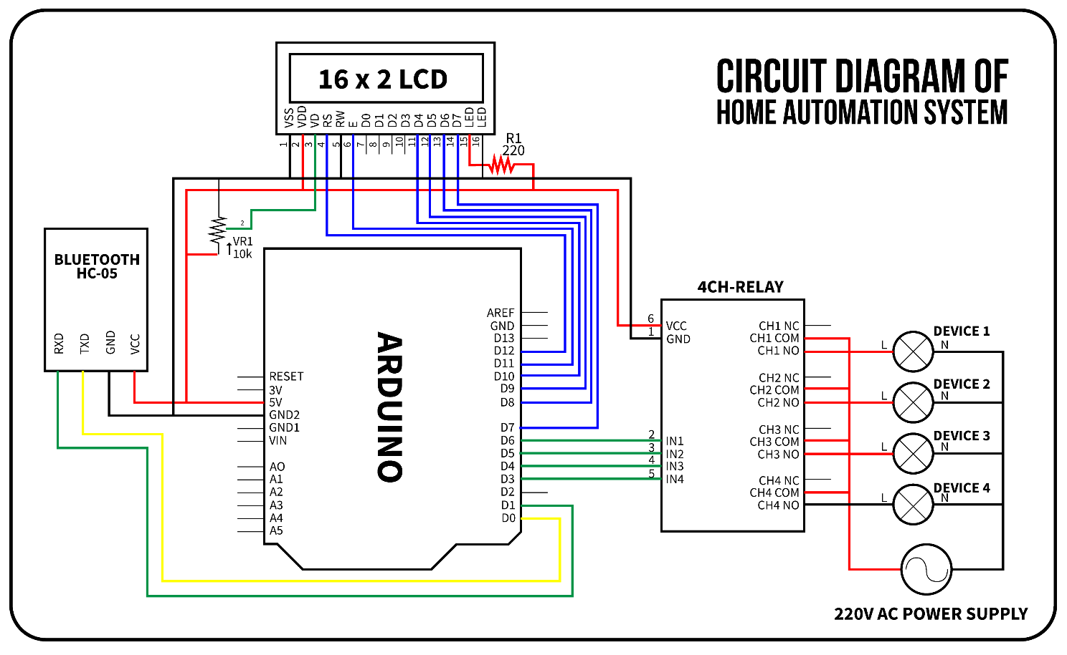

**Working Principle:**

After completing the App setup/configuration, now we need to identify the load values of the App button. The app transmits Different load values when different buttons are pressed. When we will press a button on the app, the app sends a particular Load value to the Arduino through the Bluetooth module. These Lode Values are used in Arduino code to control a particular device by a particular app button. The Load values of the App buttons and their use is described in the below list.

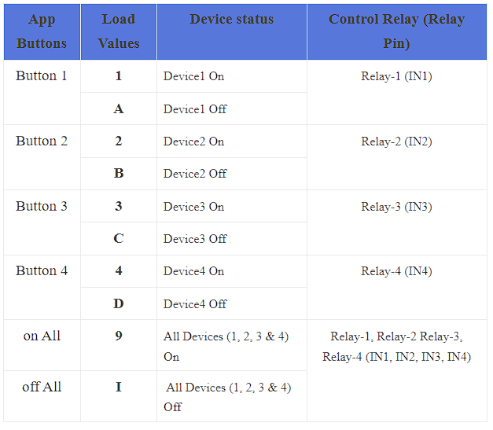

When we pressed any button of the App, the App sends a unique load value according to the button. The HC-05 Bluetooth Module received this unique load value and send it to the Arduino. Then, the Arduino compares the value with the predefined value of the button. If this value is matching then Arduino sends operating voltage to the relay module. also, we can see the Device status (on or off) on the 16×2 LCD Display.

For example, when we Press the App “Button 1“, then the app sends Load value “1” to the Bluetooth module. Then the Arduino gets this value through the Bluetooth module. Then the Arduino sends Low (0) input voltage to the Input-1 (IN1) pin of the relay module. Now the relay is in on mode. So, the Device1 will also turn on, which is connected to the relay-1 of the relay module. At the same time, the “D1 (Device 1) is ON” status print on the 16×2 LCD Display Module.

when we again Press the App “Button 1“, but this time the app sends Load value “A” to the Bluetooth module. Again, the Arduino gets this value through the Bluetooth module. But this time the Arduino sends a High(5v) input voltage to the Input-1 (IN1) pin of the relay module. Now the relay is in Off mode. So, the Device1 will also turn off, which is connected to the relay-1 of the relay module. At the same time, the “D1 (Device 1) is Off” status print on the 16×2 LCD Display Module.

**Discussion**

The smart home automation system has been experimentally proven to work satisfactory by connecting sample appliances to it and the appliances were successfully controlled from a wireless mobile device. We will be learning so many skills from this project such as soldering, wiring the circuit and other tools that we use for this project and was able to work together as a team during this project. Thus, a low-cost home automation system will be successfully designed, implemented and tested.